

|  |  |  |
| --- | --- | --- |
| Mathematics Department | |  |
| Course: A2MAA | |
| Topic Title: Test 2 Calculator Assumed | |
| Student Name:_____________________________________ | Date: ____________ | | |
| Special Instructions: Formula Sheet allowed and calculators allowed | Time Allowed: 50 minutes | | |
| **Show all working clearly** | Marks: / 40 | | |

**Question 1. [1,1:2 marks]**

Solve the following

a) $\frac{3x-7}{4}= \frac{2x-5}{3}+2$ b) $6+0.5x=\frac{x}{4}-5+\frac{x}{6}$

**Question 2. [2,1:3 marks]**

Consider the rectangle shown below.

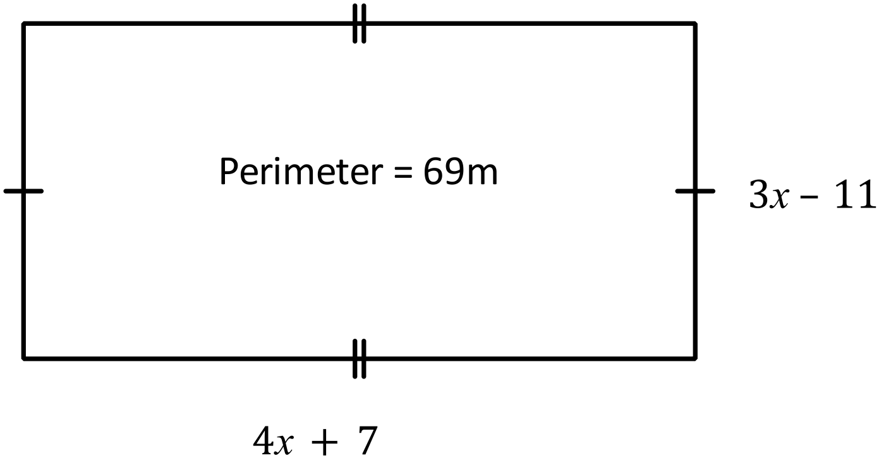

a) Determine the value of $x$.

b) Calculate the area of the rectangle.

**Question 3. [3,3:6 marks]**

Find the equation of thestraight line that passes through the points:

a) (−2, 4) and (6, −12) b) (5, 3) and (−4, 8)

**Question 4. [2,2:4 marks]**

Determine the equation of the linear relationship between $x$ and $y$

|  |  |  |  |  |  |
| --- | --- | --- | --- | --- | --- |
| $$x$$ | 2 | 3 | 4 | 5 | 6 |
| $$y$$ | 4.5 | 5 | 5.5 | 6 | 6.5 |

a)

b)

|  |  |  |  |  |  |
| --- | --- | --- | --- | --- | --- |
| $$x$$ | 4 | 5 | 6 | 7 | 8 |
| $$y$$ | 1 | -1 | -3 | -5 | -7 |

**Question 5. [3 marks]**

Use your calculator to generate a table of values for the equation

$y=0.75x-3.2$ for the domain $0≤x≤4$

|  |  |  |  |  |  |
| --- | --- | --- | --- | --- | --- |
| $$x$$ |  |  |  |  |  |
| $$y$$ |  |  |  |  |  |

**Question 6. [1,2,2,2:7 marks]**

A full storage tank is punctured and beings to slowly leak water.

The volume of the tank (*V*) in litres, *t* hours after it is punctured is given by the formula.

$V=600-12t$

a) What is the initial volume of the storage tank?

b) What is the tank’s volume after 6 hours?

c) How long will it take for the tank to lose half its initial volume?

d) What is the total time taken for the tank to completely empty?

**Question 7. [6,1,1:8 marks]**

A wholesaler offers discounts for large orders of lamps from its warehouse.

a) Complete the table

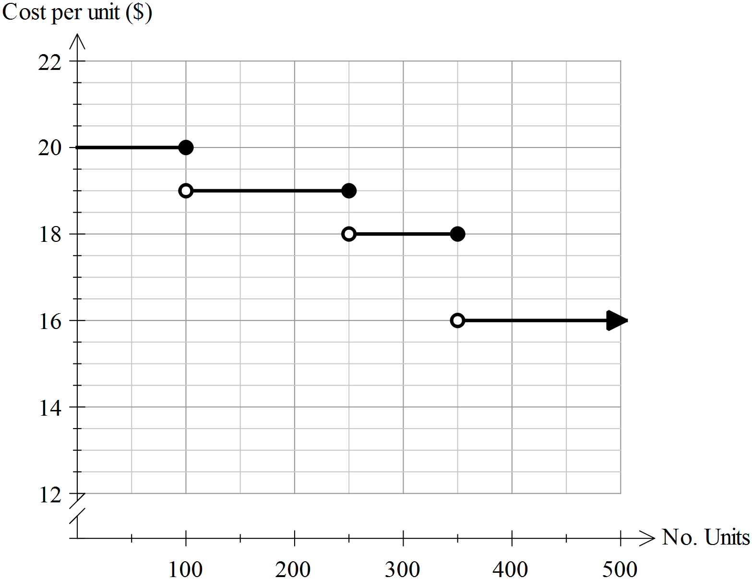

|  |  |
| --- | --- |
| Cost per Unit ($) | No of Units |
|  |  |
|  |  |
|  |  |
|  |  |

b) A small business orders 350 lamps. What is the total price of the lamps?

c) The lamps are sold to the public at $60.30 per lamp. What is the profit made on each lamp?

**Question 8. [1,4,1,1:7 marks]**

Consider the graph below. It shows the distance a cyclist travelled in the first 2 hours of his training session.

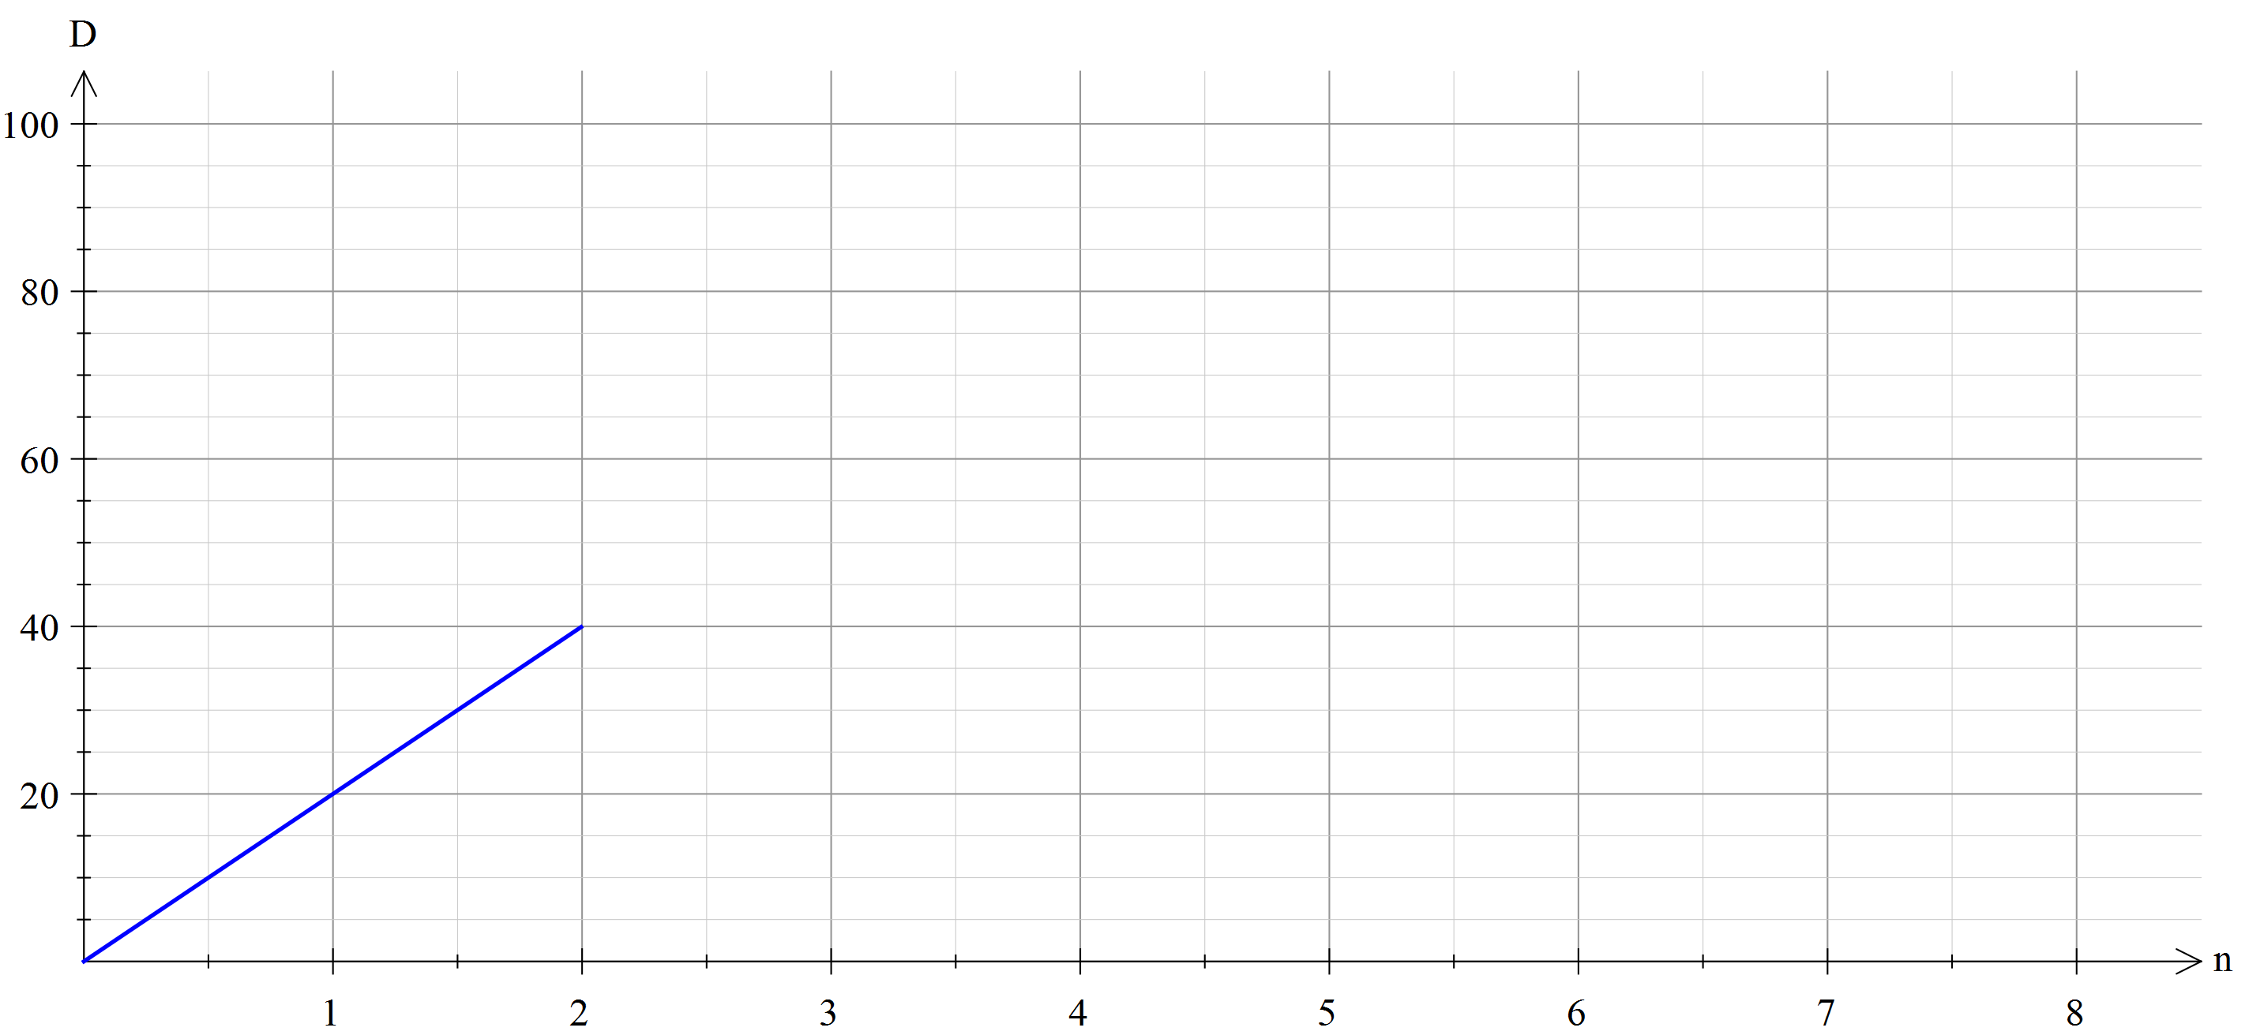

a) What is the cyclist’s average speed in km/hr in the first 2 hours of his journey?

b) The cyclist then travelled at 15 km/hr for the next 3 hours, then 9km an hour for the next 90 minutes.

Show this information on the graph.

c) At the end of the training session, how far did the cyclist travel?

d) How long was the cyclists training session?